**HOME PAGE:**

<html>

<head>

<meta charset="UTF-8">

<meta http-equiv="X-UA-Compatible" content="IE=edge">

<meta name="viewport" content="width=device-width, initial-scale=1.0">

<title>Blog : Homepage</title>

<link href="https://fonts.googleapis.com/css2?family=Poppins:ital,wght@0,400;0,500;0,600;1,600&display=swap" rel="stylesheet">

<link rel="stylesheet" href="home.css">

<style>

button {

background: #fff;

/color: #000000;/

font-weight: 600;

border: none;

padding: 12px 20px;

cursor: pointer;

border-radius: 20px;

font-size: 28px;

border: 2px solid transparent;

transition: 0.3s ease;

}

button:hover {

color: #fff;

border-color: #fff;

background: rgba(255, 255, 255, 0.15);

}

</style>

<nav class="navbar">

<style>

body {

background-image: url('home.jpg');

background-size: 1550px 850px;

background-position: center;

background-attachment: fixed;

background-repeat: no-repeat;

}

#one{

padding-left: 60px;

padding-top: 60px;

}

#two{

padding-left: 300px;

}

</style>

</head>

<body>

<div id="one">

<p style="color:rgb(21, 37, 25);font-size:60px;">Welcome To The Music World</p>

</div>

<style>

body {

background-image: url('media_imagegs/home.jpg');

background-size: 1550px 850px;

background-repeat: no-repeat;

}

</style>

</nav>

<header class="header">

<div class="content">

</h1>

<div id="two">

<button class="button"><a href="REGISTRATION.HTML">Sign up</a></button>

&nbsp;&nbsp; &nbsp;&nbsp; &nbsp;&nbsp;&nbsp;&nbsp; &nbsp;&nbsp; &nbsp;&nbsp;

<button class="button"><a href="login.html">Sign in</a></button>

</header>

</div>

</body>

</html>

**OUTPUT:**

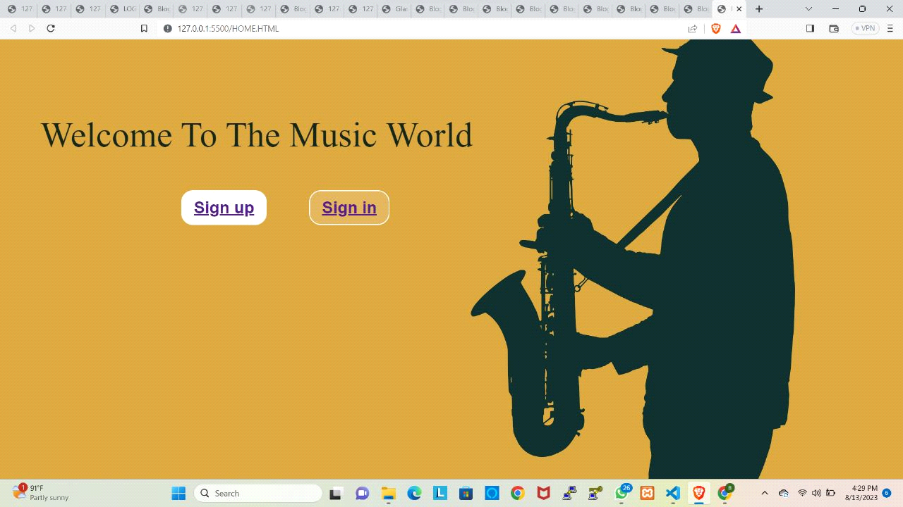

**REGISTRATION.HTML**

<!DOCTYPE>

<!-- Coding By CodingNepal - <www.codingnepalweb.com> -->

<html>

<head>

<meta charset="UTF-8">

<meta name="viewport" content="width=device-width, initial-scale=1.0">

<title>Glassmorphism Login Form | CodingNepal</title>

<link rel="stylesheet" href="REGISTRATION.CSS">

</head><body>

<div class="wrapper">

<form action="#">

<h2>Registration form</h2>

<div class="input-field">

<input type="text" required>

<label>First Name</label>

</div>

<div class="input-field">

<input type="text" required>

<label>Last Name</label>

</div>

<div class="input-field">

<input type="text" required>

<label>Email</label>

</div>

<div class="input-field">

<input type="text" required>

<label>Phone no</label>

</div>

<div class="input-field">

<input type="password" required>

<label>Password</label>

</div>

<br>

<br>

<button type="submit"> <a href="login.html">submit</a></button>

</form>

</div>

</body>

</html>

**REGISTRATION.CSS**

@import url("https://fonts.googleapis.com/css2?family=Open+Sans:wght@200;300;400;500;600;700&display=swap");

* {

margin: 0;

padding: 0;

box-sizing: border-box;

font-family: "Open Sans", sans-serif;

}

body {

display: flex;

align-items: center;

justify-content: center;

min-height: 100vh;

width: 100%;

padding: 0 10px;

}

body::before {

content: "";

position: absolute;

width: 100%;

height: 100%;

background: url("media_imagegs/REGISTER.jpg"), #000;

background-position: center;

background-size: cover;

}

.wrapper {

width: 400px;

border-radius: 8px;

padding: 30px;

text-align: center;

border: 1px solid rgba(255, 255, 255, 0.5);

backdrop-filter: blur(9px);

-webkit-backdrop-filter: blur(9px);

}

form {

display: flex;

flex-direction: column;

}

h2 {

font-size: 2rem;

margin-bottom: 20px;

color: #fff;

}

.input-field {

position: relative;

border-bottom: 2px solid #ccc;

margin: 15px 0;

}

.input-field label {

position: absolute;

top: 50%;

left: 0;

transform: translateY(-50%);

color: #fff;

font-size: 16px;

pointer-events: none;

transition: 0.15s ease;

}

.input-field input {

width: 100%;

height: 40px;

background: transparent;

border: none;

outline: none;

font-size: 16px;

color: #fff;

}

.input-field input:focus~label,

.input-field input:valid~label {

font-size: 0.8rem;

top: 10px;

transform: translateY(-120%);

}

#remember {

accent-color: #fff;

}

.forget label {

display: flex;

align-items: center;

}

.forget label p {

margin-left: 8px;

}

.wrapper a {

color: #efefef;

text-decoration: none;

}

.wrapper a:hover {

text-decoration: underline;

}

button {

background:rgb(0, 0, 0);

color: rgb(255, 255, 255);

font-weight: 600;

border: none;

padding: 10px 20px;

cursor: pointer;

border-radius: 3px;

font-size: 16px;

border: 2px solid transparent;

transition: 0.3s ease;

}

button:hover {

color: #fff;

border-color: #fff;

background: rgba(255, 255, 255, 0.15);

}

**OUTPUT:**

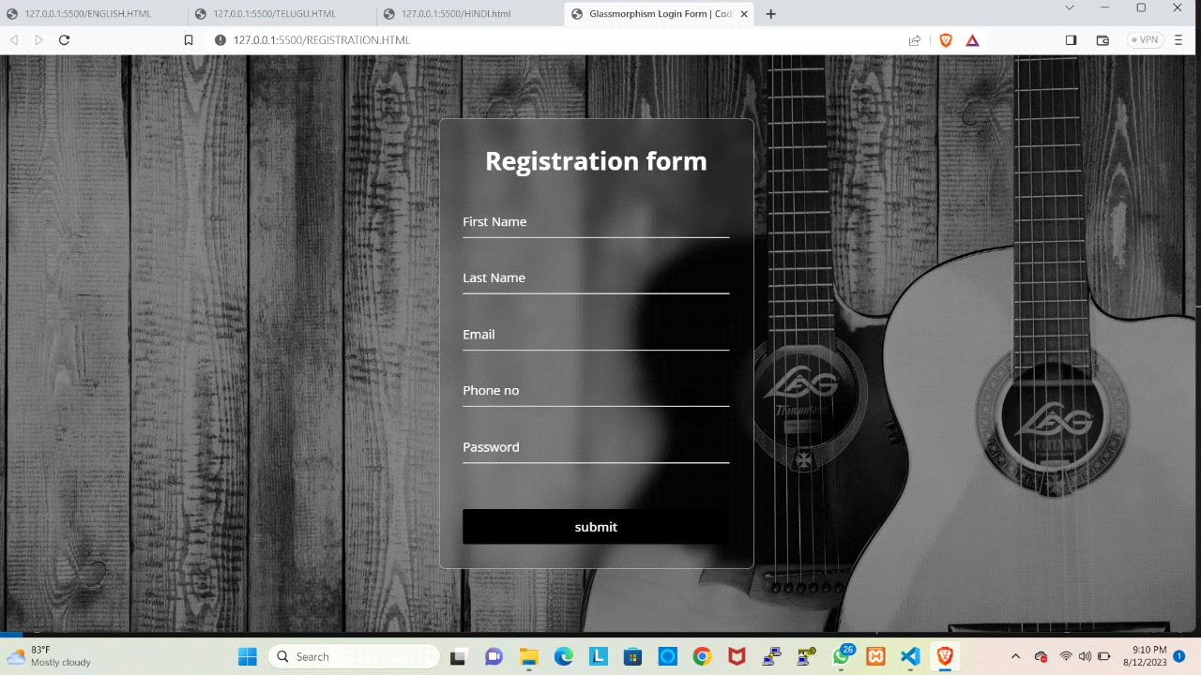

**LOGIN.HTML**

<HTML>

<HEAD>

<TITLE>LOGIN FORM</TITLE>

<style>

.button {

background-color: #000000;

border: none;

color: white;

padding: 16px 32px;

text-align: center;

font-size: 16px;

margin: 4px 2px;

opacity: 0.6;

transition: 0.3s;

display: inline-block;

text-decoration: none;

cursor: pointer;

}

.button:hover {

opacity: 1;

border: 2px solid #ffffff;}

#one{

padding: 90px;

}

</style>

</HEAD>

<body>

<style>

body {

background-image: url('media_imagegs/login.htnl.jpg');

background-size: 1530px 760px;

background-attachment: fixed;

background-position: center;

background-repeat: no-repeat;

}

</style>

</body>

<center>

<BODY>

<div id="one">

<p style="color:rgb(255, 255, 255);font-size:50px;"> Login Form</p>

<TABLE style="height:20px;color:rgb(0, 0, 0)">

<TR>

<TD>

<h2>

User Name:

</h2>

</TD>

<TD>

<h1>

<INPUT TYPE="TEXT">

</h1>

</TD>

</TR>

<TR>

<TD>

<h2>

Password:

</h2>

</TD>

<TD>

<h1>

<INPUT TYPE="PASSWORD">

</h1>

</TD>

</TR>

</TABLE>

<button class="button button1"><a href="MAIN.HTML">LOG IN</a></button>

</center>

</div>

</BODY>

</HTML>

**OUTPUT:**

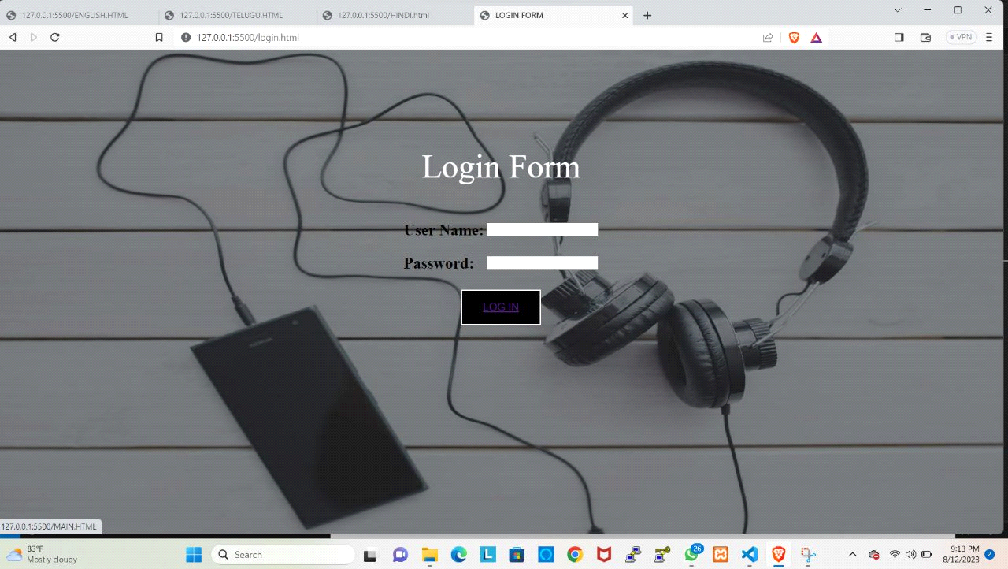

**MAIN.HTML**

<!DOCTYPE html>

<html>

<head>

<title> music blog</title>

<link rel="stylesheet" type="text/css" href="MAIN.CSS">

<link rel="stylesheet" type="text/css" href="https://stackpath.bootstrapcdn.com/font-awesome/4.7.0/css/font-awesome.min.css">

</head>

<body>

<header>

<div class="main">

</div>

<ul>

<li class="active"><a href="HOME.HTML"><i class="fa fa-home"></i>Home</a></li>

</div>

</li>

</ul>

</div>

<div class="title">

<h1>FEEL GOOD......</h1>

</div>

<div class="button">

<a href="TELUGU.HTML" class="btn">Telugu</a>

<a href="ENGLISH.HTML" class="btn">English</a>

<a href="HINDI.html" class="btn">Hindi</a>

</div>

</header>

</body>

</html>

**OUTPUT:**

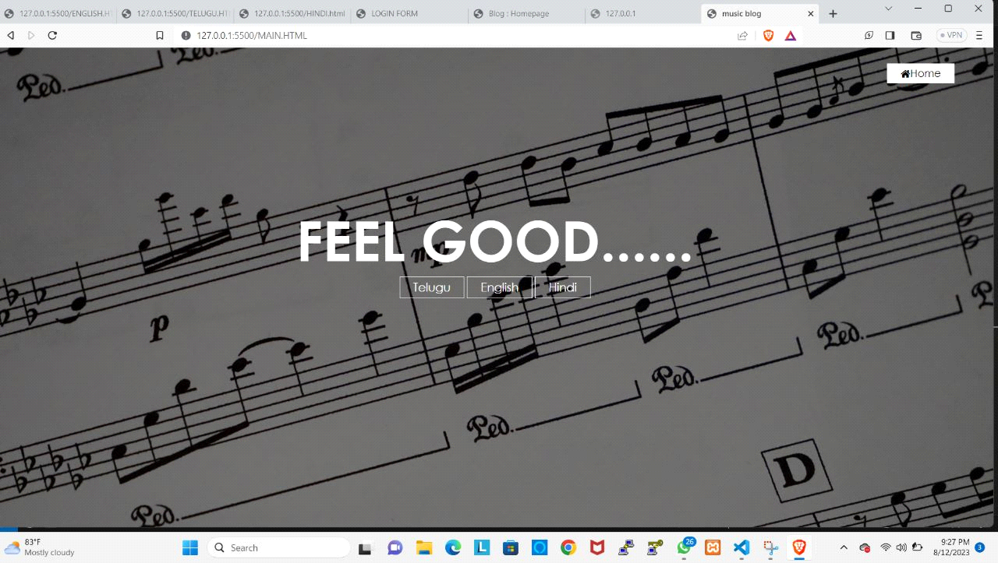

**MAIN.CSS**

{

margin: 0;

padding: 0;

font-family: Century Gothic;

}

header{

background-image:linear-gradient(rgba(0,0,0,0.5),rgba(0,0,0,0.5)), url(media_imagegs/MAIN.jpg);

height: 100vh;

background-size: cover;

background-position: center;

min-height: 100px;

}

ul{

float:right;

list-style-type: none;

margin-top: 30px;

margin-right:60px ;

}

ul li{

display: inline-block;

}

ul li a{

text-decoration: none;

color: #000000;

padding: 5px 20px;

border: 1px solid transparent;

transition: 0.5s ease;

}

ul li a:hover{

background-color: #fff;

color: #000;

}

ul li.active a{

background-color:#fff;

color: #000;

}

.logo img{

float: left;

width: 150px;

height: auto;

}

.main{

max-width: 1200px;

margin: auto;

}

.title{

position: absolute;

top: 40%;

left: 50%;

transform: translate(-50%,-50%);

}

.title h1{

color: #fff;

font-size: 85px;

}

.button{

position: absolute;

top: 50%;

left: 50%;

transform: translate(-50%,-50%);

}

.btn{

border: 1px solid #fff;

padding: 5px 20px;

color: #fff;

transition: 0.6s ease;

font-size: 18px;

text-decoration: none;

}

.btn:hover{

background-color: #fff;

color: #000;

}

.sub-menu{

display: none;

top:6%;

position: relative;

}

.sub-menu ul{

position: absolute;

}

.main ul li:hover .sub-menu

{

display: block;

position: absolute;

background-color: rgb(0,45,117);

margin-top: 12px;

margin-left: -8px;

}

.main ul li:hover .sub-menu ul

{

display: block;

margin:6px;

}

.main ul li:hover .sub-menu ul li

{

width: 75px;

padding: 5px;

border-bottom: 1px#fff;

background: transparent;

transition: 0.4s ease;

text-align: left;

border-radius: 0;

}

.main ul li:hover .sub-menu ul li:last-child

{

border-bottom: none;

}

**TELUGU>HTML**

<!DOCTYPE html>

<html>

<head>

<style>

* {

box-sizing: border-box;

}

.column {

float: left;

width: 33.33%;

padding: 5px;

}

/* Clearfix (clear floats) */

.row::after {

content: "";

clear: both;

display: table;

}

</style>

</head>

<body>

<center><h2>Telugu songs</h2></center>

<div class="row">

<div class="column">

<img src="media_imagegs/Nattu Nattu (1).avif" width="350px" height="280px"><br><p><h4>Nattu Nattu</h4></p><br><br>

<audio src="media_audio/NaatuNaatu-Rrr.mp3" controls><br>

</audio>

<p>

<h4>Movie : Roudram Ranam Rudhiram (RRR) <br>

Artists : Rahul sipligunj, kaala Bhairava<br>

Released : 2022 <br>

</h4>

</p>

</div>

<div class="column">

<img src="media_imagegs/ooruperu.jpg" width="350px" height="280px"><br><p><h4>Nijamene Chebuthunna</h4></p><br><br>

<audio src="media_audio/Nijamene Chebuthunna - Telugu ! Song.mp3" controls><br>

</audio>

<p>

<h4>Movie : Ooru Peru BhaiEravakona <br>

Artists : Sid Sriram <br>

Released : 2023 <br>

</h4>

</p>

</div>

<div class="column">

<img src="media_imagegs/Beats-Of-Radhe-Shyam-1200.avif" width="350px" height="280px"><br><p><h4>Nagumomu Taarale</h4></p><br><br>

<audio src="media_audio/Nagumomu Thaarale - Radhey Shyam - Telugu Song.mp3" controls><br>

</audio>

<p>

<h4>Movie : Radhe Shyam <br>

Artists : Sid Sriram <br>

Released : 2022 <br>

</h4>

</p>

</div>

</div>

<div class="row">

<div class="column">

<img src="media_imagegs/sitaramam.webp" width="350px" height="280px"><br><p><h4>Oh sita</h4></p><br><br>

<audio src=" media_audio/Telugu Naa Songs Mp3 - Oh Sita - Sitaramam Movie.mp3" controls><br>

</audio>

<p>

<h4>Movie : SitaRamam <br>

Artists : SPB Charan, Sinduri <br>

Released : 2022 <br>

</h4>

</p>

</div>

<div class="column">

<img src="media_imagegs/thiru.jpg" width="350px" height="280px"><br><p><h4>Na Madhi puvvu adi</h4></p><br><br>

<audio src=" media_audio/Telugu Thiru Songs - Naa Madhi.mp3" controls><br>

</audio>

<p>

<h4>Movie : Thiru<br>

Artists : Dhanunjay Seepana <br>

Released : 2022 <br>

</h4>

</p>

</div>

<div class="column">

<img src="media_imagegs/jaanu.jpg" width="350px" height="280px"><br><p><h4>BGM</h4></p><br><br>

<audio src="media_audio/Jaanu Songs Naa Ventapadi.mp3 " controls><br>

</audio>

<p>

<h4>Movie : Jaanu<br>

Artists : BGM<br>

Released : 2021<br>

</h4>

</p>

</div>

</div>

</body>

</html>

**Output:**

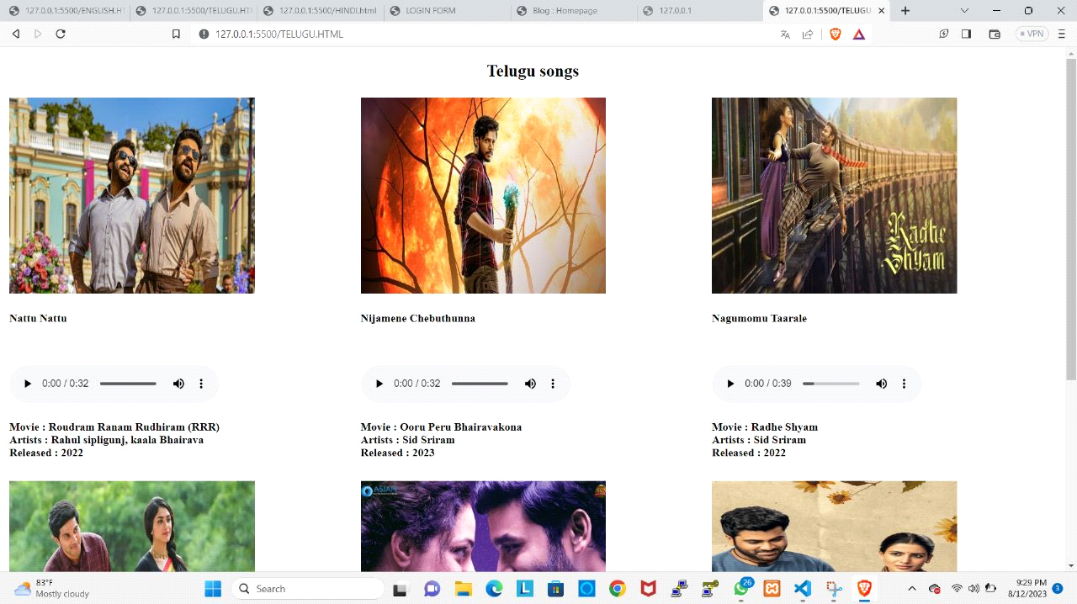

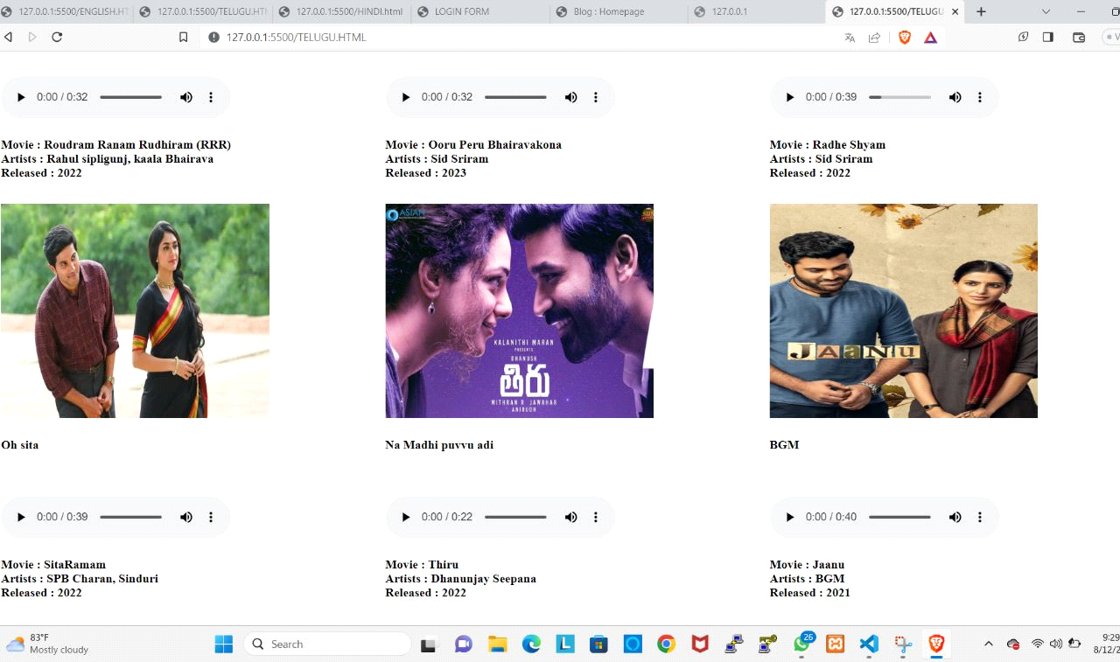

**HINDI.HTML**

<!DOCTYPE html>

<html>

<head>

<style>

* {

box-sizing: border-box;

}

.column {

float: left;

width: 33.33%;

padding: 5px;

}

/* Clearfix (clear floats) */

.row::after {

content: "";

clear: both;

display: table;

}

</style>

</head>

<body>

<center><h2>Hindi songs</h2></center>

<div class="row">

<div class="column">

<img src="media_imagegs/zara-hatke-zara-bachke.jpg" width="350px" height="280px"><br><p><h4>Tere Vaaste</h4></p><br><br>

<audio src="media_audio/Tere Vaaste - Tere Vaaste Main Falak Se ! Hindi Song.mp3" controls><br>

</audio>

<p>

<h4>Movie : zara-hatke-zara-bachke <br>

Artists : Varun Jain, Sachin- Jigar, Shadab Faridi, and Altamash Faridi<br>

Released : 2023<br>

</h4>

</p>

</div>

<div class="column">

<img src="media_imagegs/Mimi-1.jpg " width="350px" height="280px"><br><p><h4>Param Param Sundari</h4></p><br><br>

<audio src="media_audio/Parama Sundari - Mimi - Kriti Sanon - Hindi Song.mp3" controls><br>

</audio>

<p>

<h4>Movie : Mimi <br>

Artists : Shreya Ghoshal <br>

Released : 2021 <br>

</h4>

</p>

</div>

<div class="column">

<img src="media_imagegs/aashiki.jpg" width="350px" height="280px"><br><p><h4> Tum Hi Ho</h4></p><br><br>

<audio src="media_audio/Tum hi ho song.mp3" controls><br>

</audio>

<p>

<h4>Movie : Aashiqui 2 <br>

Artists : Arijit singh <br>

Released : 2013 <br>

</h4>

</p>

</div>

</div>

div class="row">

<div class="column">

<img src="media_imagegs/549052-377387-dheere-dheere-hrithik-sonam.avif" width="350px" height="280px"><br><p><h4>Dheere Dheere</h4></p><br><br>

<audio src=" media_audio/Dheere Dheere Song.mp3" controls><br>

</audio>

<p>

<h4>Movie : Dheere Dheere <br>

Artists : Anuradha Paudwal, Kumar Sanu<br>

Released : 2015<br>

</h4>

</p>

</div>

<div class="column">

<img src="media_imagegs/dhoni.jpg " width="350px" height="280px"><br><p><h4>kaun tujhe</h4></p><br><br>

<audio src="media_audio/kaun_tujhe_2018.mp3 " controls><br>

</audio>

<p>

<h4>Movie : MS Dhoni<br>

Artists : Palak Muchal <br>

Released : 2016<br>

</h4>

</p>

</div>

<div class="column">

<img src="media_imagegs/shershaah.jpg" width="350px" height="280px"><br><p><h4> Raataan Lambiyan</h4></p><br><br>

<audio src="media_audio/Raataan Lambiyan Lambiyan - Shershaah.mp3" controls><br>

</audio>

<p>

<h4>Movie : Shershaah <br>

Artists : Jubin Nautiyal, Asees Kaur<br>

Released : 2021 <br>

</h4>

</p>

</div>

</body>

</html>

**OUTPUT:**

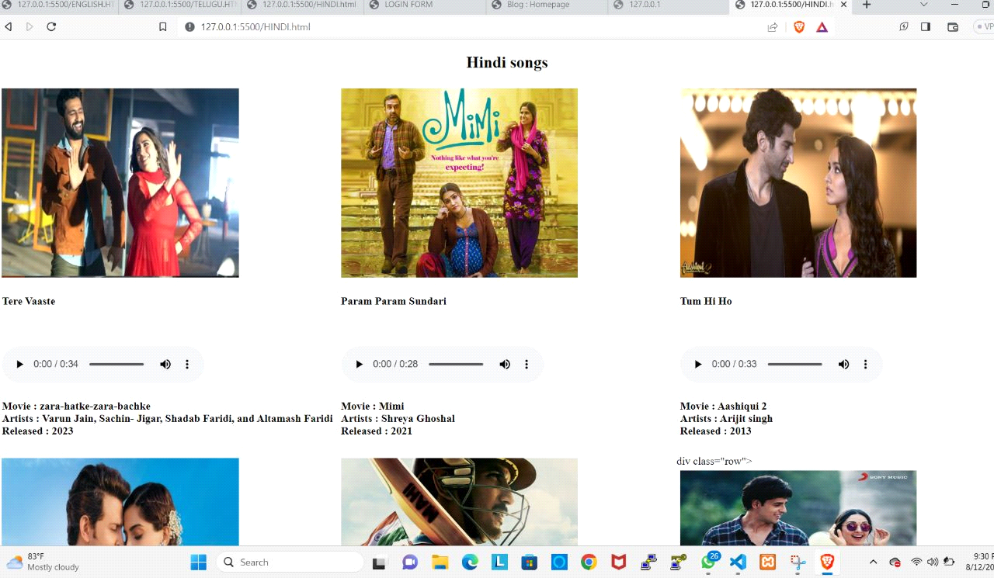

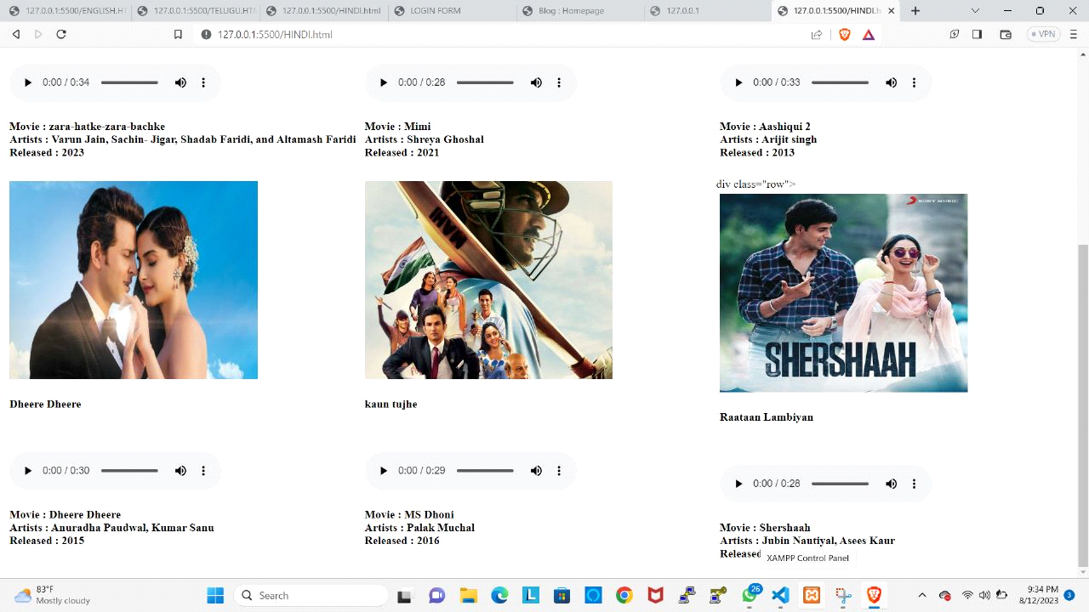

**ENGLISH.HTML**

<!DOCTYPE html>

<html>

<head>

<style>

* {

box-sizing: border-box;

}

.column {

float: left;

width: 33.33%;

padding: 5px;

}

/* Clearfix (clear floats) */

.row::after {

content: "";

clear: both;

display: table;

}

</style>

</head>

<body>

<center><h2>English songs</h2></center>

<div class="row">

<div class="column">

<img src="media_imagegs/safari img.jpg" width="350px" height="280px"><br><p><h4>Safari</h4></p><br><br>

<audio src="media_audio/safary.mp3" controls><br>

</audio>

<p>

<h4>Song name : Safari<br>

Album name : Serena<br>

Singer name : Joshua Michael Kiszka<br>

</h4>

</p>

</div>

<div class="column">

<img src=" media_imagegs/letmeimg.jpg" width="350px" height="280px"><br><p><h4>Let_Me_Love_You</h4></p><br><br>

<audio src="media_audio/let_me_love_you.mp3" controls><br>

</audio>

<p>

<h4>

Song name : let me love you<br>

Album name : DJ snake<br>

Singer name : Justin Bieber<br>

</h4>

</p>

</div>

<div class="column">

<img src="media_imagegs/worstimg.jpg" width="350px" height="280px"><br><p><h4> At My Worst</h4></p><br><br>

<audio src="media_audio/At My Worst.mp3" controls><br>

</audio>

<p>

<h4>

Song name : At My Worst<br>

Album name : Pink Sweats <br>

Singer name :David Bowden<br>

</h4>

</p>

</div>

</div>

<div class="row">

<div class="column">

<img src="media_imagegs/safari img.jpg" width="350px" height="280px"><br><p><h4>Senorita</h4></p><br><br>

<audio src="media_audio/Senorita English.mp3" controls><br>

</audio>

<p>

<h4>Song name : Senorita<br>

Album na me : Serena<br>

Singer name : Shawn Mendes, Camila Cabello<br>

</h4>

</p>

</div>

<div class="column">

<img src=" media_imagegs/letmeimg.jpg" width="350px" height="280px"><br><p><h4>Baby Baby</h4></p><br><br>

<audio src="media_audio/justin_bieber_baby.mp3 " controls><br>

</audio>

<p>

<h4>

Song name : Baby<br>

Album name : DJ snake<br>

Singer name : Justin Bieber<br>

</h4>

</p>

</div>

<div class="column">

<img src="media_imagegs/worstimg.jpg" width="350px" height="280px"><br><p><h4> Believer</h4></p><br><br>

<audio src="media_audio/believer_song.mp3" controls><br>

</audio>

<p>

<h4>

Song name : Believer<br>

Album name : Pink Sweats <br>

Singer name :David Bowden<br>

</h4>

</p>

</div>

</div>

</body>

</html>

**Output:**

